**Assignment 22.2**

1. **Find out what are the top 5 categories with maximum number of videos uploaded.**

**DRIVER:**

In driver set the task, job configuration and Input and Output format.

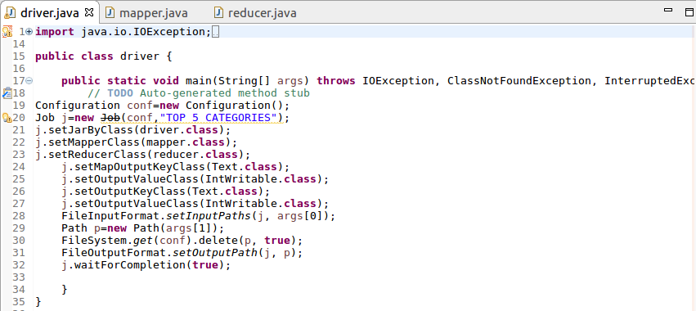

**Mapper:**

Since we want the top 5 categories split the data and then send category as key and a count of 1 as value.

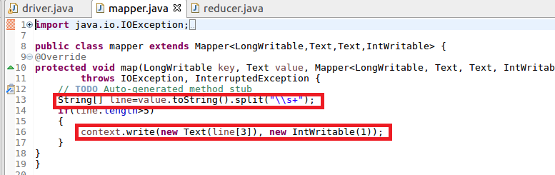

**Reducer:**

In reducer, the total count for each category is made by the iterating values.

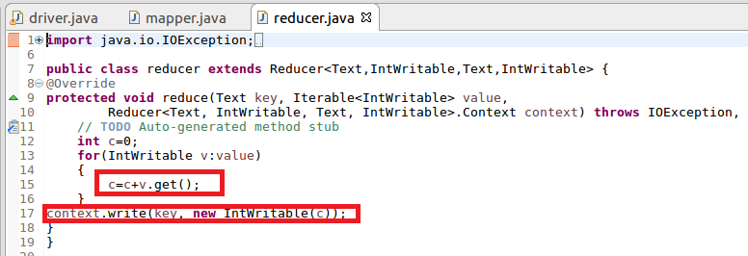

**Running jar:**

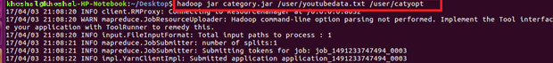

**Output:**

Since we want top 5 categories we can use sort –n –k2 –r |head –n5 where k2 represents the 2 column (value column)based on which sorting should be done and the -r is used for sorting in recursively(reverse order) and head –n5 gives the top 5.



1. **Find the top 10 rated videos in you tube.**

**Driver:**

In driver set the task, job configuration and Input and Output format.

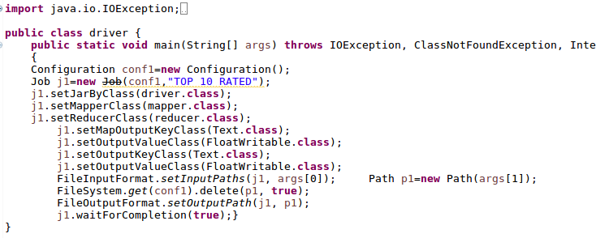

**Mapper:**

Since we want the top 10 rated videos split the data and then send video as key and a rating as value.

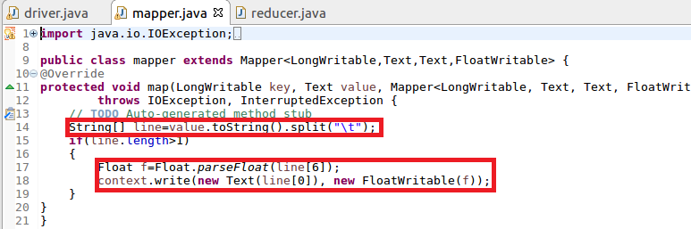

**Reducer:**

In reducer we will sum the rating for each video and find the average rating for each video.

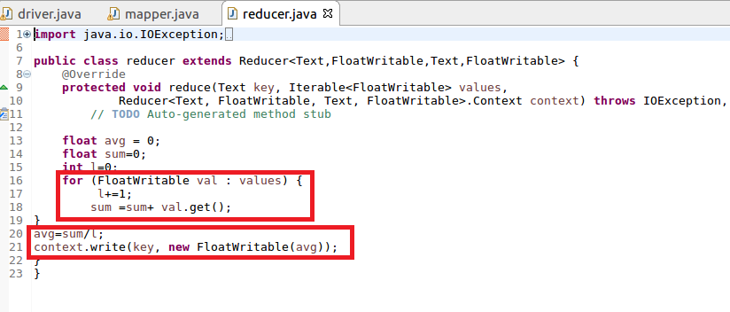

**RUNNING JAR:**

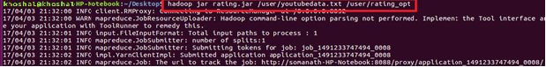

**Output:**

Since we want top 10 ratings we can use sort –n –k2 –r |head –n10 where k2 represents the 2 column (value column)based on which sorting should be done and the -r is used for sorting in recursively(reverse order) and head –n10 gives the top 10.

